The Fight

10/16/16

Ephesians 6:10 Finally, my brethren, be strong in the Lord and in the power of His might.
- Know who you are _______________.

Ephesians 6:12 For we do not wrestle against flesh and blood, but against principalities, against powers, against the rulers of the darkness of this age, against spiritual hosts of wickedness in the heavenly places.
- _________________
- _________________
- _________________
- _________________

- Realize you have a ___________________.

Notes:____________________________________________________________________________________________________________________________________________________________________________________________________________

Luke 4:43 NAS But he said to them, I must preach the kingdom of God to the other cities also, for I was sent for this purpose.
- Purpose challenges our _______________.
- Purpose drives you to _____.
- Know who you are fighting for.

- Allow God to ________ you.

Ephesians 6:13 Therefore take up the whole armor of God, that you may be able to withstand in the evil day, and having done all, to stand.
- To win you need the __________ equipment.
- To win most effectively use what you have been __________.
Notes:_________________________________________________________________________________________________________________________________
- You do not fight __________.

2 Corinthians 2:14 Now thanks be to God who always leads us in triumph in Christ, and through us diffuses the fragrance of His knowledge in every place.

- Listen to your ____________________.
- Lean on your _________.

- Keep a clear ______________________.
- Understand who your ____________ is.
John 10:10 The thief does not come except to steal, and to kill, and to destroy. I have come that they may have life, and that they have it more abundantly.
- Understand what is really at _____________.
Notes:_______________________________________________________________________________________________________________________________________________________________________________________________
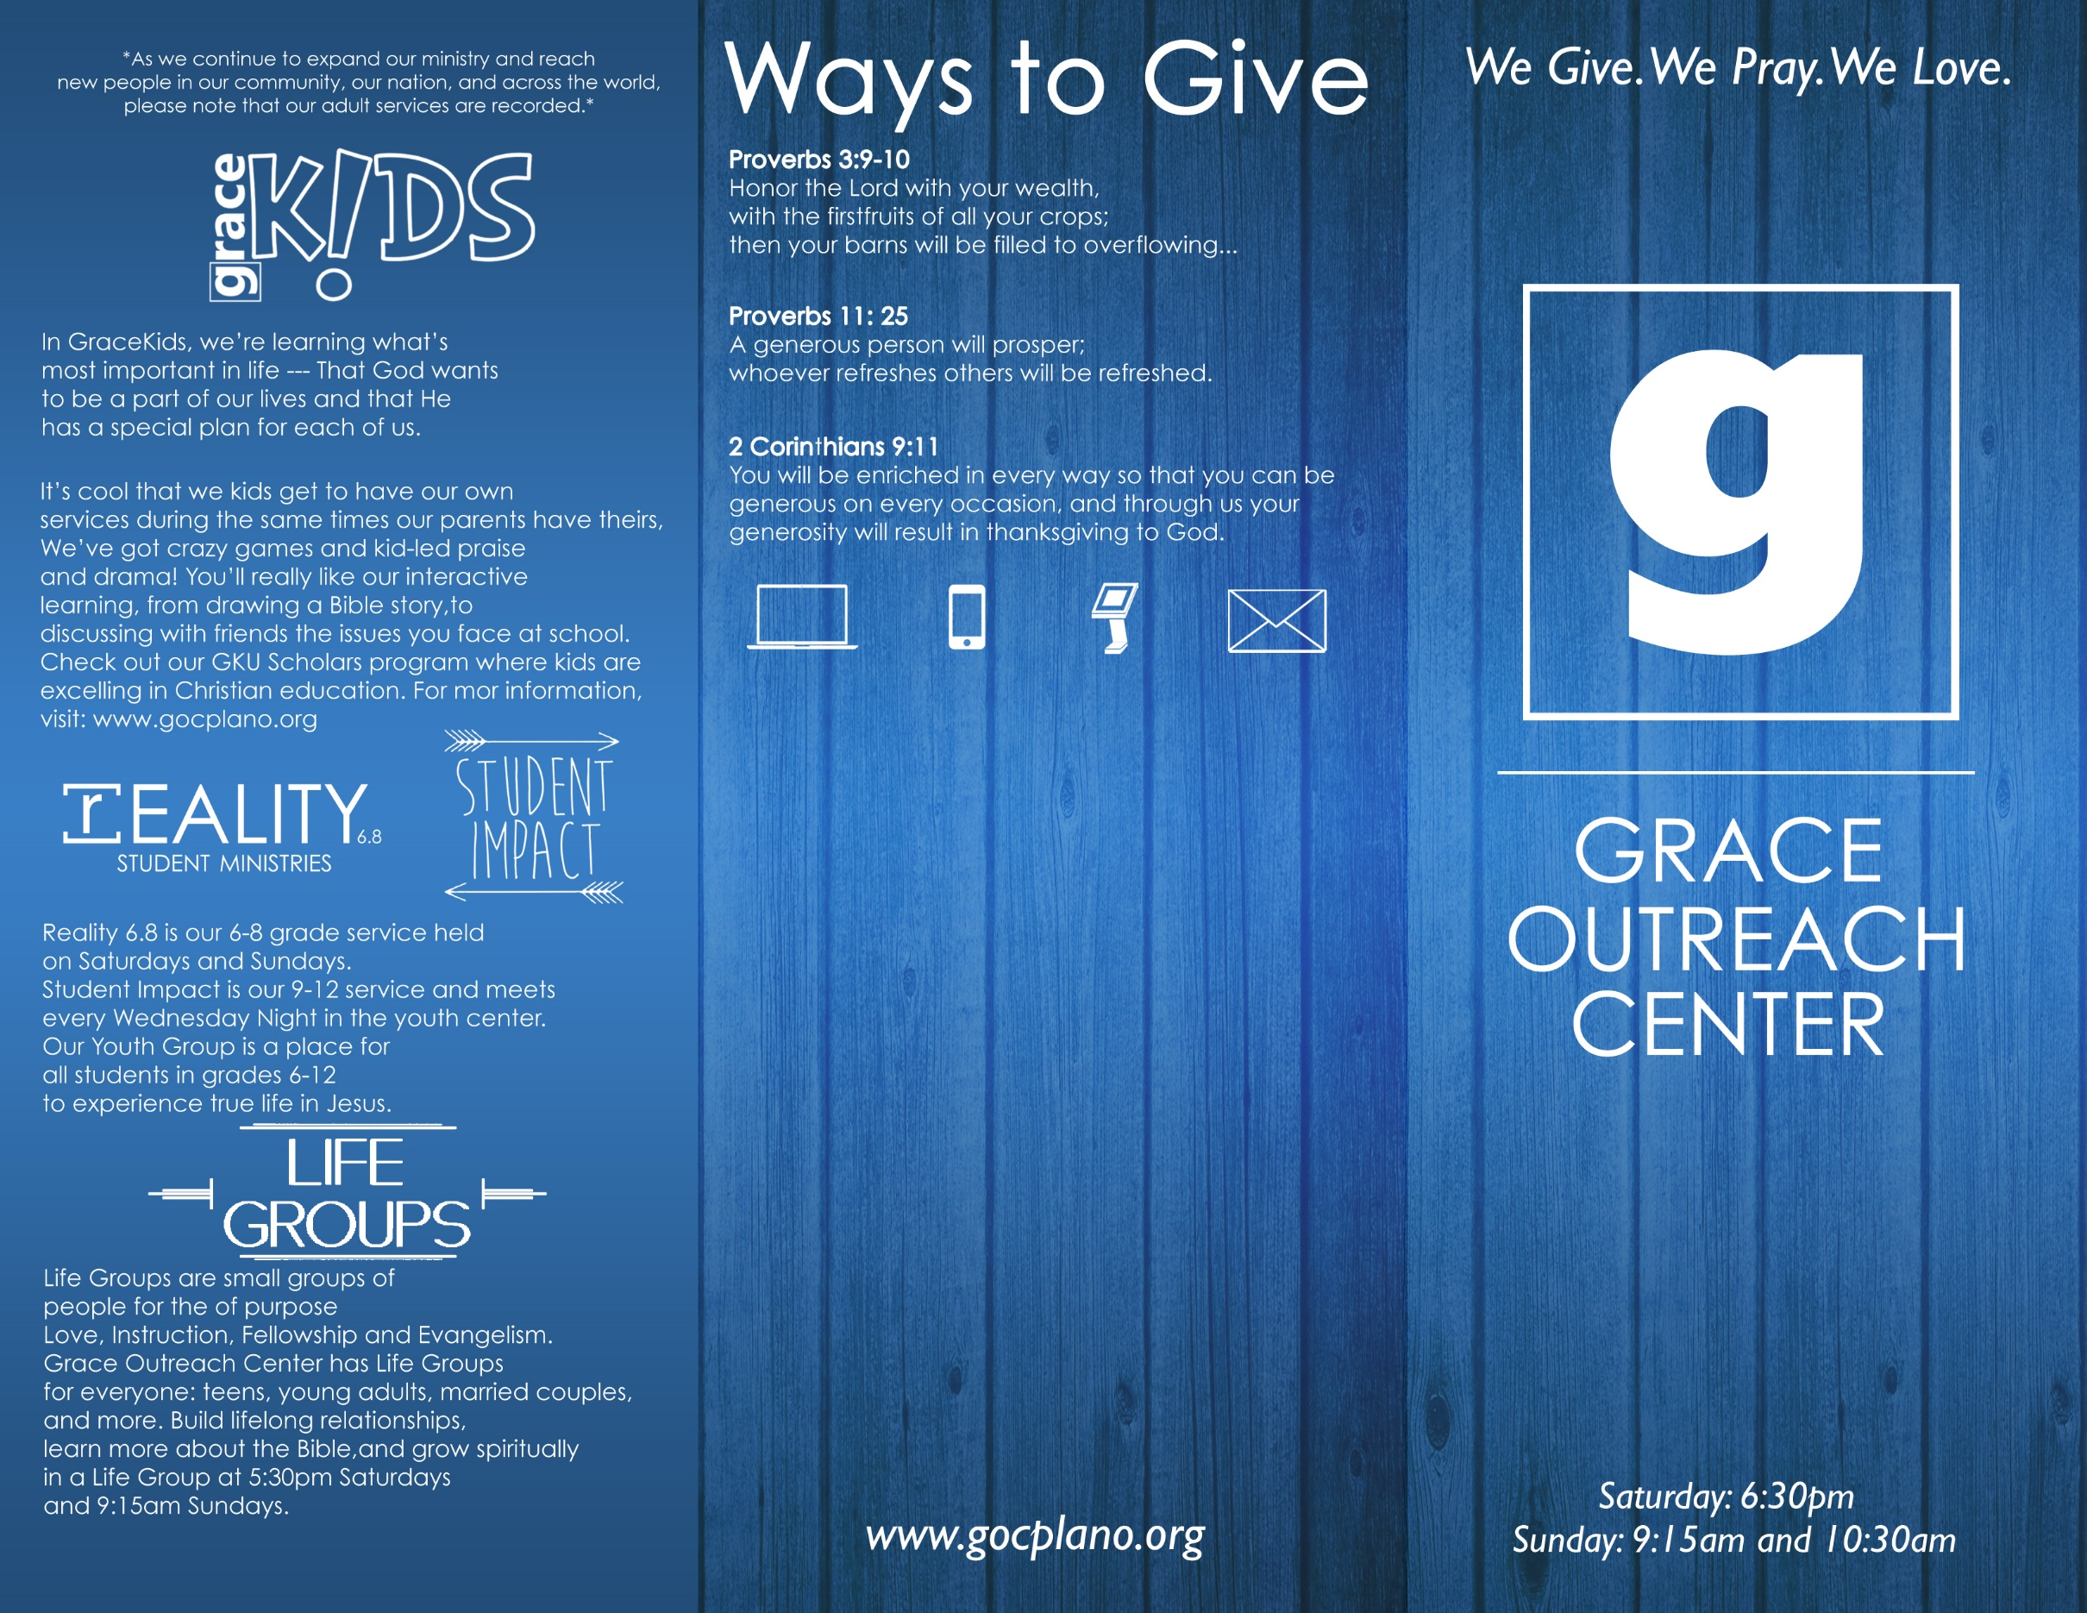
FPU Workshops- The Financial Peace team will be hosting their second workshop Oct. 16 and will discuss basics on buying a home. The class will be at 12:15pm in Room 245. To RSVP for this event please email lifegroups@gocplano.org or show up on Sunday.
GraceKids Community Christmas Project! Kids, raise $5 to help us buy t-shirts for a Plano school in need. Bring to GraceKids by Nov. 20.

October 15-16, 2016

